Mail User Agent (MUA)

💌 What is a MUA (Mail User Agent)?
# Source: AI Source: Provided by: [Data Path: Persons Table -> ID Column: 1, Name_En Column: Motasem Essam] -> From: [Chatgpt (GPT‑5 Mini)] on [1/21/2026]
A MUA (Mail User Agent) also called email client is simply the program or app you use to send, receive, read, and write emails.

📱 Examples of MUAs
# Source: AI Source: Provided by: [Data Path: Persons Table -> ID Column: 1, Name_En Column: Motasem Essam] -> From: [Chatgpt (GPT‑5 Mini)] on [1/21/2026]
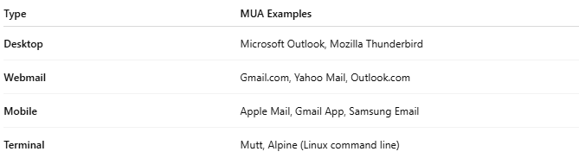
Type | MUA Examples
Desktop | Microsoft Outlook, Mozilla Thunderbird
Webmail | Gmail.com, Yahoo Mail, Outlook.com
Mobile | Apple Mail, Gmail App, Samsung Email
Terminal | Mutt, Alpine (Linux command line)
In short: Any app that you interact with to manage email is a Mail User Agent (MUA).

🧠 What Does a MUA Do?
# Source: AI Source: Provided by: [Data Path: Persons Table -> ID Column: 1, Name_En Column: Motasem Essam] -> From: [Chatgpt (GPT‑5 Mini)] on [1/21/2026]
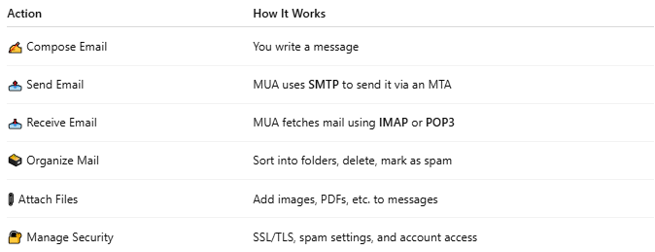

Action | How It Works
✍️ Compose Email | You write a message
📤 Send Email | MUA uses SMTP to send it via an MTA
📥 Receive Email | MUA fetches mail using IMAP or POP3
🗃 Organize Mail | Sort into folders, delete, mark as spam
📎 Attach Files | Add images, PDFs, etc. to messages
🔐 Manage Security | SSL/TLS, spam settings, and account access

🏗 MUA in Email Architecture
# Source: AI Source: Provided by: [Data Path: Persons Table -> ID Column: 1, Name_En Column: Motasem Essam] -> From: [Chatgpt (GPT‑5 Mini)] on [1/21/2026]
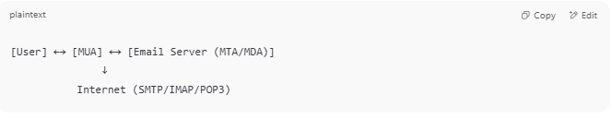
[User] ←→ [MUA] ←→ [Email Server (MTA/MDA)]
↓
Internet (SMTP/IMAP/POP3)

- MUA = Email client
- MTA (Mail Transfer Agent) = Sends/receives mail between servers
- MDA (Mail Delivery Agent) = Puts mail in your inbox

🔁 MUA vs MTA vs MDA
# Source: AI Source: Provided by: [Data Path: Persons Table -> ID Column: 1, Name_En Column: Motasem Essam] -> From: [Chatgpt (GPT‑5 Mini)] on [1/21/2026]
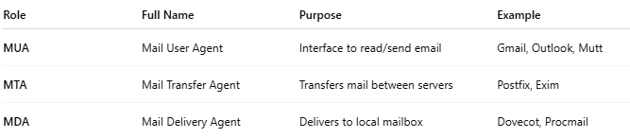
Role | Full Name | Purpose | Example
MUA | Mail User Agent | Interface to read/send email | Gmail, Outlook, Mutt
MTA | Mail Transfer Agent | Transfers mail between servers | Postfix, Exim
MDA | Mail Delivery Agent | Delivers to local mailbox | Dovecot, Procmail

is same SMTP Client
# Source: AI Source: Provided by: [Data Path: Persons Table -> ID Column: 1, Name_En Column: Motasem Essam] -> From: [Chatgpt (GPT‑5 Mini)] on [1/21/2026]
Great question! While MUA (Mail User Agent) and SMTP Client are closely related, they are not exactly the same — but they often overlap.

🔍 The Difference: MUA vs SMTP Client
# Source: AI Source: Provided by: [Data Path: Persons Table -> ID Column: 1, Name_En Column: Motasem Essam] -> From: [Chatgpt (GPT‑5 Mini)] on [1/21/2026]
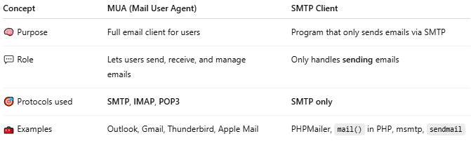

Concept | MUA (Mail User Agent) | SMTP Client
🧠 Purpose | Full email client for users | Program that only sends emails via SMTP
💬 Role | Lets users send, receive, and manage emails | Only handles sending emails
🎯 Protocols used | SMTP, IMAP, POP3 | SMTP only
🧰 Examples | Outlook, Gmail, Thunderbird, Apple Mail | PHPMailer, mail() in PHP, msmtp, sendmail

🔁 How They're Connected
# Source: AI Source: Provided by: [Data Path: Persons Table -> ID Column: 1, Name_En Column: Motasem Essam] -> From: [Chatgpt (GPT‑5 Mini)] on [1/21/2026]
- MUAs include an SMTP client inside them to send messages.
- SMTP clients can also be standalone programs that aren’t full MUAs.

🧪 Example Breakdown
# Source: AI Source: Provided by: [Data Path: Persons Table -> ID Column: 1, Name_En Column: Motasem Essam] -> From: [Chatgpt (GPT‑5 Mini)] on [1/21/2026]
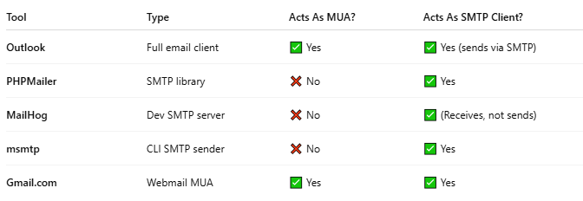

Tool | Type | Acts As MUA? | Acts As SMTP Client?
Outlook | Full email client | ✅ Yes | ✅ Yes (sends via SMTP)
PHPMailer | SMTP library | ❌ No | ✅ Yes
MailHog | Dev SMTP server | ❌ No | ✅ (Receives, not sends)
msmtp | CLI SMTP sender | ❌ No | ✅ Yes
Gmail.com | Webmail MUA | ✅ Yes | ✅ Yes

✅ Summary
# Source: AI Source: Provided by: [Data Path: Persons Table -> ID Column: 1, Name_En Column: Motasem Essam] -> From: [Chatgpt (GPT‑5 Mini)] on [1/21/2026]
✅ A Mail User Agent (MUA) is a full-featured email app.
✅ An SMTP Client is a component (or standalone tool) used to send emails via SMTP.
All MUAs have an SMTP client, but not all SMTP clients are MUAs.

✅ Summary
# Source: AI Source: Provided by: [Data Path: Persons Table -> ID Column: 1, Name_En Column: Motasem Essam] -> From: [Chatgpt (GPT‑5 Mini)] on [1/21/2026]
A Mail User Agent (MUA) is your email client — the software that lets you compose, send, and receive emails. It talks to servers using SMTP, IMAP, or POP3, and is the main tool users interact with.

